ABC Solutions
Tools: Excel + Python
10 Analysis Parts
38 Tasks
150 Employees
Departments: HR • Sales • IT

Part 1 — Data Understanding & Descriptive Statistics

1.1 Variable Classification
Variable | Category | Scale
Employee_ID |  | Discrete
Age | Numerical | Discrete
Department | Categorical | -
Education_Level | Categorical | -
Experience | Numerical | Discrete
Training_Hours | Numerical | Discrete
Performance_Score | Numerical | Discrete
Before_Training | Numerical | Discrete
After_Training | Numerical | Discrete
Salary | Numerical | Continuous
Website | Categorical | -
Conversion | Categorical | -
Izoh: Agar experience/hours butun son bo’lmaganda(30.5, 2.4 kabi) Continuous ishlatilar edi

1.2 Data Quality Checks

Missing Values
Datasetda null/bo’sh qiymatlar topilmadi | 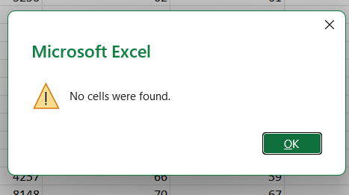
Bu excelda: Home => Find & Select => Go To Special => Blanks => OK

Duplicate Records
Yozilgan kod datasetdagi dublicate valueni aniqlash va o’chirib yuborish uchun ishlaydi
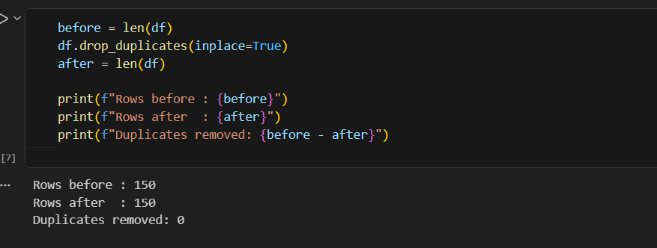
Outlier Detection — Boxplots
Interpretation | Excel
Excelda Box and Whisker Plot orqali Salary taqsimoti tahlil qilindi. Rasmdagi bitta nuqta whiskerdan tashqarida joylashgan. Bu bitta outlier borligini bildiradi. Outlier qiymati ekremal darajada uzoq emas. Shuning uchun bu keying hisob kitoblarga ma’lum darajada tasir qilishi mumkin, lekin uni buzib yuborish darajasida emas. Shuning uchun bu outlier qoldirildi. | 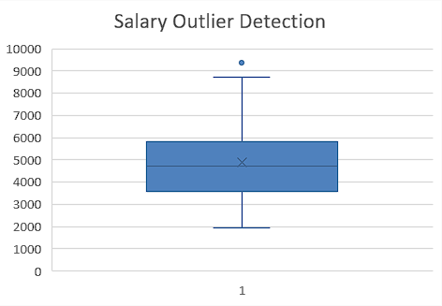
Performance Score uchun qilingan Box and Whicker Plot tahlilida hech qanday outlier aniqlanmadi. Plotdan shuni ko’rish mumkinki, Performance Score normal taqsimlangan | 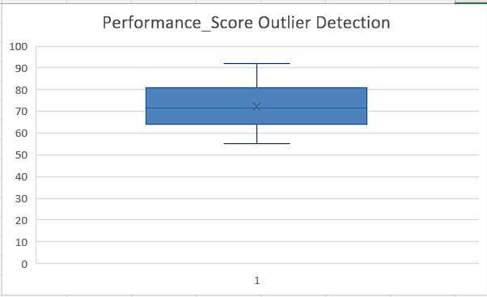

1.3 Descriptive Statistics
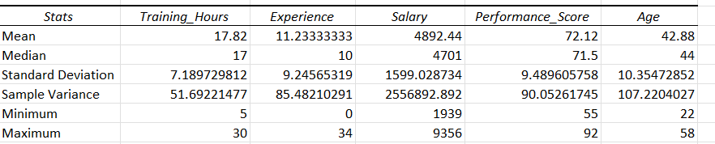

1.4 Distribution Analysis
📊 Interpretation | Excel
Skewness(Assimitriya): 0.53  Salary bo’yicha qilingan histogram shuni ko’rsatadiki, Salaryda o’rtacha pozitiv assimitriya bor. Histogram o’ng tomonga og’gan. Asosiy salary qiymatlar 3000 va 6000 o’rtasida taqsimlangan. Data normal taqsimlanmagan. Lekin kuchli asssimitrik ham emas. | 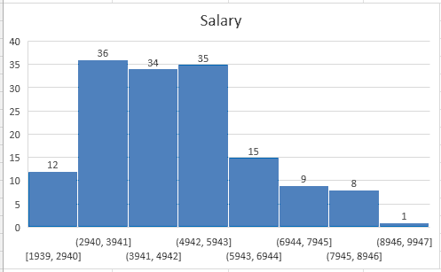
Skewness: 0.19  PS bo’yicha qilingan histogramda biroz o’ng tomonga pozitiv og’ish bor. Umumiy skewness < 0.3 qoidasiga ko’ra, PSda ham deyarli normal distribution bor. | 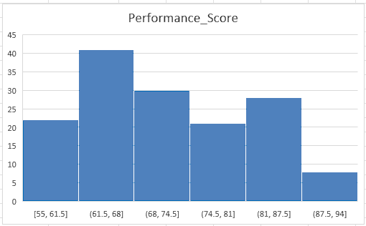

Part 2 — Probability Distributions

2.1 Is Salary Normally Distributed?
Kurtosis – bu data Ichida outlierlarning va distributionning shape yassilik darajasini o’lchaydigan kattalik. Agar u Excelda o’lchanganda ≈ 0 ga teng bo’lsa, data to’liq bell-shaped ya’ni normal distributed hisoblanadi. Agar 0 dan katta bolsa High kurtosis, 0 dan kichik bo’lsa Low kurtosis hisoblanadi.
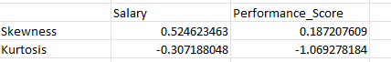
Descriptive Statistikada Salary Kurtosisi taqriban -0.31 ga teng. Kurtosisi qiymati 0 dan katta bo’lgani uchun Salaryning katta qismi markazda joylashgan, lekin chetlarda tails yani outliers bor. Buni yuqorida keltirilgan histogramdan ham bilish mumkin. Salary normally Distributed emas.

2.2 Conversion Variable — Distribution Choice
Conversion Variable Distribution Analysis
Datasetda Conversion o‘zgaruvchisi quyidagicha beirlgan:
- 0 - Did Not Convert
- 1 - Converted
Ya’ni har bir kuzatuv faqat ikki xil natijadan birini qabul qilishi mumkin: success yoki failure. Shu sababli Conversion variable uchun eng mos distribution Binomial Distribution hisoblanadi.
Binomial Distribution Shartlari
Biror o‘zgaruvchi Binomial Distributionga mos kelishi uchun quyidagi shartlar bajarilishi kerak:
1. Fixed Number of Trials- Triallar soni oldindan ma’lum bo‘lishi kerak.
Tekshirish: Datasetda Conversion ustunida 150 ta kuzatuv mavjud. Demak, triallar soni aniq berilgan.
2. Only Two Possible Outcomes - Har bir trial faqat ikki xil natijaga ega bo‘lishi kerak: success yoki failure.
Tekshirish: Conversion ustunida faqat 0 va 1 qiymatlari mavjud.
- 1 = Success (Convert)
- 0 = Failure (Did Not Convert)
3. Constant Probability of Success - Har bir trialda success ehtimoli bir xil bo‘lishi kerak.
Tekshirish: Har bir foydalanuvchi uchun conversion hodisasi bir xil jarayon asosida kuzatiladi va success ehtimoli p deb belgilanadi.
4. Independence of Trials - Bir trial natijasi boshqa trial natijasiga ta’sir qilmasligi kerak.
Tekshirish: Bir foydalanuvchining saytga convert qilishi boshqa foydalanuvchining convert qilish ehtimoliga ta’sir qilmaydi.
Yuqoridagi shartlarning barchasi bajarilganligi sababli, Conversion variable Binomial Distribution ga mos keladi. Shuning uchun Conversion bo‘yicha Analysis qilish jarayonida Binomial Distributiondan foydalanish Kerak.

2.3 Conversion Probability P(Conversion=1)
Interpretation | Formula
Conversion Probability quyidagi formula bilan hisoblandi. Convert qilgan userlar soni jami userlar soniga bo’lindi. Natijada 0.46 hosil bo’ldi. Ya’ni 46% userlar convert qilgan. Xulosa, 150 ta employeening 46 % I conversionni amalga oshiradi | 

Part 3 — Correlation Analysis

3.1 Choosing the Right Method
Condition | Method
Experience ↔ Salary | Pearson
Age ↔ Salary | Pearson
Training_Hours ↔ Performance_Score | Pearson
Education_Level ↔ Salary | Spearman

3.2 Running Correlations in Excel
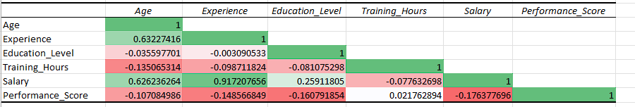
Interpretation
Experience ↔ Salary o’rtasida juda kuchli bog’lanish (0.92) kuzatildi. Bu degani, ko’proq tajribaga ega bo’lgan xodimlar ko’proq maosh oladi.

Age ↔ Salary bog’lanishi tahlil qilinganda, ular orasida o’rtacha darajadagi bog’lanish (0.63) borligi aniqlandi. Ya’ni, Ba’zi hollarda Katta yoshdagi xodimlar ko’proq maosh olishlari mumkin, lekin bu aniq kuchli korrelatsiya bilan isbotlanmadi.

Training_Hours ↔ Performance_Score o’rtasida juda kuchsiz bog’lanish aniqlandi(0.022). Shuni xulosa qilish mumkinki, ko’p train qilish yuqori Performance Score olish degani emas.

Education_Level ↔ Salary - heatmapdan ko’rish mumkinki, ular orasida kuchsiz bog’lanish mavjud(0.26) Salary ni baland bo’lishiga Education Level kuchli ta’sir ko’rsatmaydi kabi xulosaga kelishimiz mumkin.

Part 4 — Simple & Multiple Regression

4.1 Simple Linear Regression: Experience → Salary
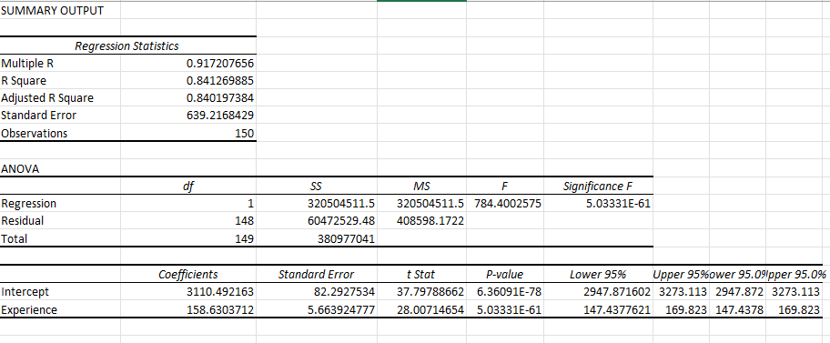
Interpretation
Regression Equation: Predicted Salary = b₀ + b × Experience
Masalan: Predicted Salary = 3110.5+ 158.6 × Experience
• b (slope): Har bir qo’shimcha bir yil tajriba uchun boshlang’ich tajriba qiymatiga 158.6 dan qo’shiladi
• Intercept: Salary o’zgarishini boshlang’ich nuqtasi - 3110.5
• R²: Salaryni oshishi 84 foiz (R² * 100) Experiencega bog’liq.
• p-value < 0.05: 6.36^78 0.05 dan kichik bo’lgani sababli, bu bog’lanish stattistik jihatdan muhim.

4.2 Multiple Regression: Age + Experience + Education + Training → Salary
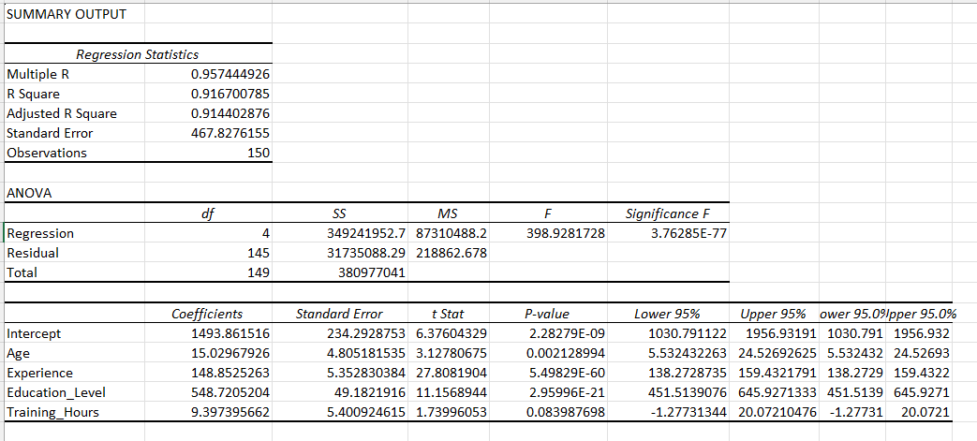
Interpretation
• Age (slope): Har bir yosh uchun Salary 15 ga ortyabti
p-value – 0.0021< 0.05: Age va Salary relationshipi statistic jihatdan muhim
• Experience (slope): Experience 1 yilga ortsa Salary 148.9 ga ortyabti
p-value – 5.5^-60< 0.001: Experience Oshganda Salary ham oshishi statistic jihatdan juda muhim
• Education_Level (slope): Education Level bir pog’ona yaxshilanganda, Salaryga 548.7 qo’shilyabti
p-value – 2.96^-21<0.001: EL va Salary o’rtasida real, juda kuchli bog’liqlik borligi statistic jihatdan
isbotlandi
• Training_Hours (slope): Har bir qo’shimcha hour uchun Salary 9.4 ga oshyabti
p-value – 0.084 >0.05: Training_Hours va Salary o’rtasidagi relationship tasodif bo’lishi mumkin.
Ular orasida muhim bog’liqlik yo’q

• Intercept: Salary o’zgarishini boshlang’ich nuqtasi – 1493.9
• R²: Salaryni oshishi 92 foiz (R² * 100) Quyidagi 4 ta factorga bog’liq.
• p-value < 0.05: 6.36^78 0.05 dan kichik bo’lgani sababli, bu bog’lanish stattistik jihatdan muhim.

4.3 Scatter Plot with Regression Line
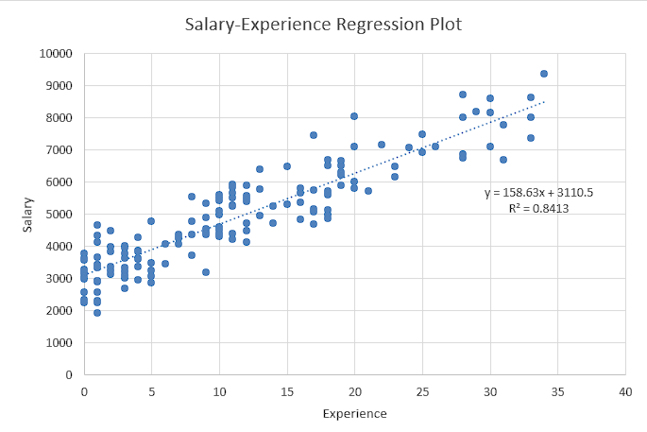
Interpretation
Bu Scatter Plot Salary va Experience o’rtasidagi bog’liqlikni ko’rsatadi.
Regression tenglama: y = 158.63x + 3110.5
Har bir 1 yil Experience uchun Salary o’rtacha 158.63 ga oshadi. Agar tajriba 0 bolsa, bo’lmasa boshlang’ich maosh 3110.5 ga teng. Bu degani tajribasiz ishchi ham shuncha maosh olishi mumkin.
R² = 0.8413 – bu shuni ko’rsatadiki, Salaryning tahminan 84 foizi Experiencega bog’liq. Qolganf 16 foizi esa boshqa factorlarga bog’liq.

Part 5 — Hypothesis Testing

5.1 Research Question: Does Training Improve Performance?
H₀ | Trainingni ta’siri yo’q
H₁ | Training Performanceni yaxshilaydi
Test Type | Paired t-test( bir xil obyekt 2 marta o’lchanadi

5.2 Running the Test
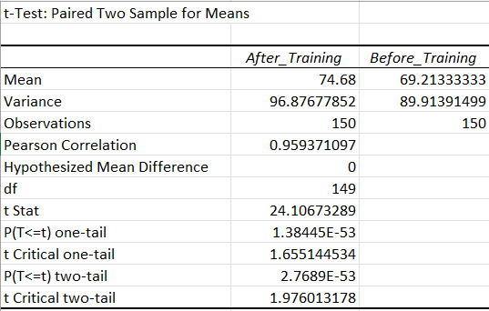
Interpretation
t Stat: 24.11
P(T<=t) one-tail: 1.38*10^-53
t Critical one-tail: 1.66
Difference: 5.47
Tahlil natijalariga ko‘ra, t-statistic qiymati (t = 24.11) kritik qiymatdan (t critical = 1.66) ancha katta bo‘lib, bu ikki guruh o‘rtasida statistik jihatdan ahamiyatli farq mavjudligini ko‘rsatadi. Shuningdek, p-value (1.38 * 10^-53) juda kichik bo‘lib, bu natijaning tasodifiy yuzaga kelish ehtimoli deyarli nolga teng ekanligini bildiradi. Shu sababli, null gipoteza (H₀) rad etiladi va alternativ gipoteza qabul qilinadi.
Agar before_training mean va after_taraining mean farqi ham hisobga olinsa, 5.47 Gipoteza birni tasdiqlaydi, va natija tasodif emasligini, Chindan ham Training qilish Performanceni yaxhsilashini isbotlaydi.

Part 6 — ANOVA: Department Performance Comparison

6.1 One-Way ANOVA Setup
Departmentlar soni 2 tadan ko’p bo’lgani uchun ANOVA tanlandi va keying tahlillar 3 ta department o’rtasidagi farqni analiz qiladi.
H₀ | Barcha departmentlar bir xil.
H₁ | Kamida bitta guruh qolganlaridann far qiladi.

6.2 Running ANOVA
Interpretation | Formula
Datasetdagi Performance_Score Department bo’yicha guruhlanmagani uchun yangi table yaratildi. Unda quyidagi formula yordamida har bir departmentga tegishli scorelar alohida columnga ajratildi. | 

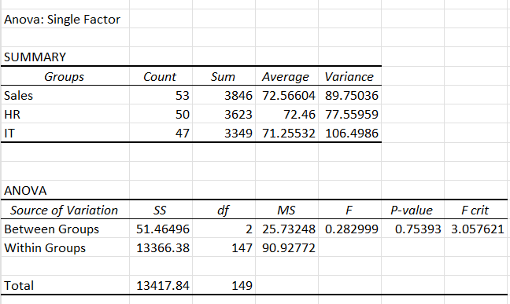
Interpretation
F: 0.28
P-value: 0.75
F crit: 3.06
Sales Mean: 72.6
HR Mean: 72.5
IT Mean: 71.3

Agar har bir departmentning mean performance_Score ni solishtiradigan bo’l’sak, deyarli farq yo’q. Bu H0 gipotezani tasdiqlashi mumkin. Buni ANOVA orqali ham tekshiramiz:
F-statistics – bu guruhlar o’rtasidagi farqni har bir guruhdan qanchali farqliligini ko’rsatadi.
F=0.28 <Fkritik​=3.06
guruhlararo farq tasodifiy xatolik darajasidan katta emas.

Qoida bo’yicha agar p-value 0.05 dan kichik bo’lsa H0 rad etiladi. Lekin bu vaziyatda p-value 0.05 dan katta:
0.75>0.05.
Shuning uchun ham H- rad etilmaydi
Tahlil natijalari shuni ko‘rsatadiki, Sales, HR va IT bo‘limlari o‘rtasidagi o‘rtacha ko‘rsatkichlar deyarli bir xil darajada.
Sales bo’limida mean value biroz yuqori bo’lsa ham bu statistic jihatdan ishonchli emas.

Part 7 — A/B Testing (Website Conversion)

7.1 Hypothesis & Test Design
A/B Testing A Website va B Website o’rtasidagi conversion rateni taqqoslash uchun ishlatiladi.
H₀ | No difference in conversion rates
H₁ | Website B has higher conversion
Alpha | 0.05

7.2 Calculating Conversion Rates
Interpretation | Formula
Data Analysis Toolpack da A/B Testing yo’qligi uchun uni formulalar orqali hisoblaymiz.  Conversion va Website_Group ustunidan yangi pivot table yaratiladi.  Conversion Rate hiosblanadi  CR=Converted/Total  Difference=CRA-CRB  Website B guruh CRi Website A guruh CRiga nisbatan 25% yuqori natija ko’rsatdi.  Bu natija Chi-Square Test yordamida isbotlandi. Formula yordamida hisoblanganda 0 ga teng bo’ldi. Excelda natija juda kichik son bo’lgani uchun 0 ga tenglashtirdi. Bu o’z o’zidan p-value 0.05 dan kichik ekanini va H0 rad etilishini, B Website A Websitedan yaxshiroq ekanini isbotlaydi | 